High School World History

Mr. Cramer Sande
Email: cramer.sande@tumwater.k12.wa.us
Twitter: @MrSande14
Facebook: Search Cramer Sande
Course Description
The goal of this course is to familiarize students with the concepts and connections that have led us to the world we live in today. History allows us to view the past under a microscope, examining the cause and effect factors, major characters, and specific details that can easily be overlooked. Ultimately, students will have opportunities to learn major skills that will be used for the rest of their lives. Developing an argument, using evidence to back up that argument, analytical skills to determine valid pieces of evidence will help students become better citizens in an ever changing society. This class will be spent less on gross memorization of names and dates, and more on learning these skills and using them to understand the journey of history to the present.

Responsibilities
- Work to your best potential!
- Treat everyone here with civility.
  - Understand there are different perspectives. It is okay to agree to disagree. Any “jokes” made that are offensive (ethnic, religious, racial, sexual slurs) are not funny and are not to be used here.
- Come to class prepared to learn with the proper materials and attitude.
- Leave all grudges and prejudices at the door.

Attendance/Tardies
The current school policy of loss of credit at 11 days absent will be followed in World History. Getting to class on time is much like arriving to a job on time. Luckily, you won't be fired from my class. Students are given three tardies. Preceding tardies will result in a phone call (or email) home and a 30 minute detention will be assigned. Continuing tardies will result in better interventions to help class be more of a priority.

Technology
Social Studies classes have been blessed with the opportunity to have Chromebooks available for frequent use. We will be using these devices often to emphasize analytical thinking and writing skills in World History, but also to enhance your understanding of particular topics. Chromebooks are not your cell phone or iPod; they are not meant to check your social media. They are not meant to play games. Failure to follow these rules will result in disciplinary procedures.
Cell Phone Use
Cell phones cause distractions. Although they are useful pieces of academic technology, most students do not use them for this purpose. Very little of what is covered in class will be synthesized into your memory while using a device. Therefore, cell phones and iPods are not allowed unless I give time in class to use them. If a student is caught using their phone, it will be confiscated. First offenders will receive their device back at the end of class. Two or more offenses will result in the device being sent to the office.
Evaluation
Students will be graded based upon their performance on homework quizzes, projects, presentations, and chapter/unit tests. Attendance will significantly influence your grade as well. Grading will follow the following format:
90% = assessments (quizzes, tests, essays, projects, presentations)
10% = engaged learning (notes, journals, in-class activities, homework)
Assessment Retakes:
Students will have an opportunity to retake an assessment in order to demonstrate increased proficiency or mastery of the standard. The retake score will replace the original score. To be eligible for retakes, the student must have all work turned in for the unit we are on. Students will also be required to conduct further studying and/or activities before retaking a particular assessment. Examples may include resubmitting a study guide for a chapter test, or showing sources to back up changes made to a presentation.

Late Work
For each day a student misses class that is excused, he or she will have that many days to make up the missing work. For example, if you miss one day and it is excused, you have one extra day to make up the homework missed. Students who do not make up work within the time allotted will receive half credit. Failure to turn in work during a specific chapter will result in a zero on that assignment. If you know you will be missing class because of an emergency, please see me ahead of time and we can work together to get you the proper homework assignments.

Discipline
As responsible citizens, you are required to act appropriately in class. Behavior that disrupts the class in any way or is inappropriate will be dealt with in the following procedure:
- 1st offense: student(s) will be asked to leave class and wait in the hall until the teacher allows him or her to come back in
- 2nd offense: student(s) will be asked to leave class and ½ hour detention will be issued.
- 3rd offense: student(s) will be sent to the office and be issued 1 hour detention.
- 4th offense: see student handbook for harsher punishments

Drinks and Snacks
Students are only allowed to drink liquids with a screw-on cap. Water will always be allowed and students may leave the classroom to get a drink with permission. To decrease the amount of messy spills, drinks like soda, coffee, etc. without a closable lid will not be allowed. Students who bring these in will be required to finish them outside of class or leave them in the back of the classroom to be picked up at the end of the period. Snacks are under the same scrutiny but are a little more acceptable. Snacks may not be a class disruption or make a mess. Discipline will be given for those who do not follow these rules.

Bathroom Use
As young adults, you know when you need to use the restroom or not. Yet, as a member of THS, it is your job to be using your time academically, not wandering the halls checking your cell phone. When you do choose to leave the room for this, you must submit a cell phone or mobile device. If you do not have either of these, something else of equal value will suffice. This will be returned to you when you re-enter the classroom. If you have nothing to leave with the teacher, you will not be using the restroom. You will also be required to sign out of the room on a sheet by the door. When you return, please mark the time that you do so.

These rules may be subject to change throughout the school year to keep a safe learning environment for all students.

Questions? Do not hesitate to contact me via phone, email, twitter, etc.

Course Overview:

Themes:
Students in this course must learn to view history thematically. The AP World History course is organized around five overarching themes that serve as unifying threads throughout the course, helping students to relate what is particular about each time period or society to a “big picture” of history. The themes also provide a way to organize comparisons and analyze change and continuity over time. Consequently, virtually all study of history in this class will be tied back to these themes by using a “SPICE” acronym.

Social - Development and Transformation of Social Structures
- Gender roles and relations
- Family and kinship
- Racial and ethnic constructions
- Social and economic classes

Political - State-building, Expansion, and Conflict
- Political structures and forms of governance
- Empires
- Nations and nationalism
- Revolts and revolutions
- Region, trans-regional, and global structures and organization

Interaction Between Humans and the Environment
- Demography and disease
- Migration
- Patterns of settlement
- Technology

Cultural - Development and Interaction of Cultures
- Religions
- Belief Systems, philosophies, and ideologies
- Science and technology
- The arts and architecture

Economic - Creation, Expansion, and Interaction of Economic Systems
- Agriculture and pastoral production
- Trade and commerce
- Labor systems
- Industrialization
- Capitalism and socialism

Test Overview and Units
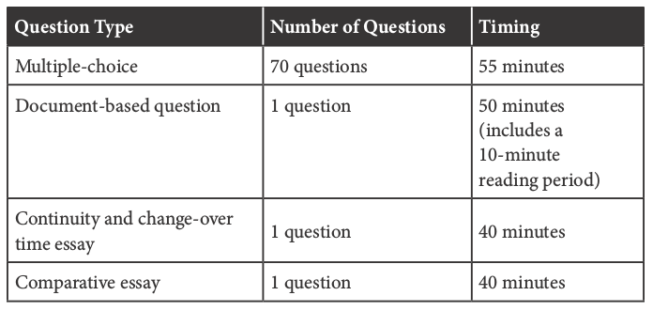

The FRQs: Free Response Questions
- DBQ/EBQ: The Document/Evidence Based Question
- CCOT: Continuity & Change Over Time
- COMP: Comparative Essay
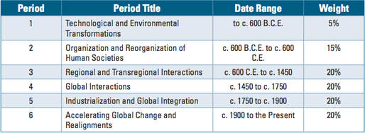
Remember, 50% of your AP Test Score = FRQs.

